SANSKAR SEHGAL
OS LAB 1 CSE C 58 07/12/20 180905486

1. GREP

#include<unistd.h>
#include<sys/stat.h>
#include<fcntl.h>
#include<stdlib.h>
#include <string.h>
#include<stdio.h>

int main(int argc, char const *argv[])
{
if(argc!=3)
{
write(2, "There should be 3 arguments specified\n", 38);
exit(1);
}

int sfd = open(argv[2], O_RDONLY); //source file descriptor
printf("%s\n", argv[1] );
if(sfd==-1)
{
write(2, "Source file does not exist\n", 27);
exit(1);
}

char line[100]="";
char c;
int no_of_lines = 0;
// argv[0] - binary filename currently being executed
// argv[1] - additional argument 1
// argv[2] - additional argument 2

while(read(sfd, &c, sizeof(char))>0)
// while(read(sfd, &c, sizeof(char))!=0)
{
if(c!='\n')
{
strncat(line, &c, 1);
}
else
{
no_of_lines++;
if(strstr(line, argv[1])!=NULL)
{
printf("Line %d: %s\n",no_of_lines, line );
}
line[0] = '\0';
}
}
close(sfd);
return 0;
}
Output:

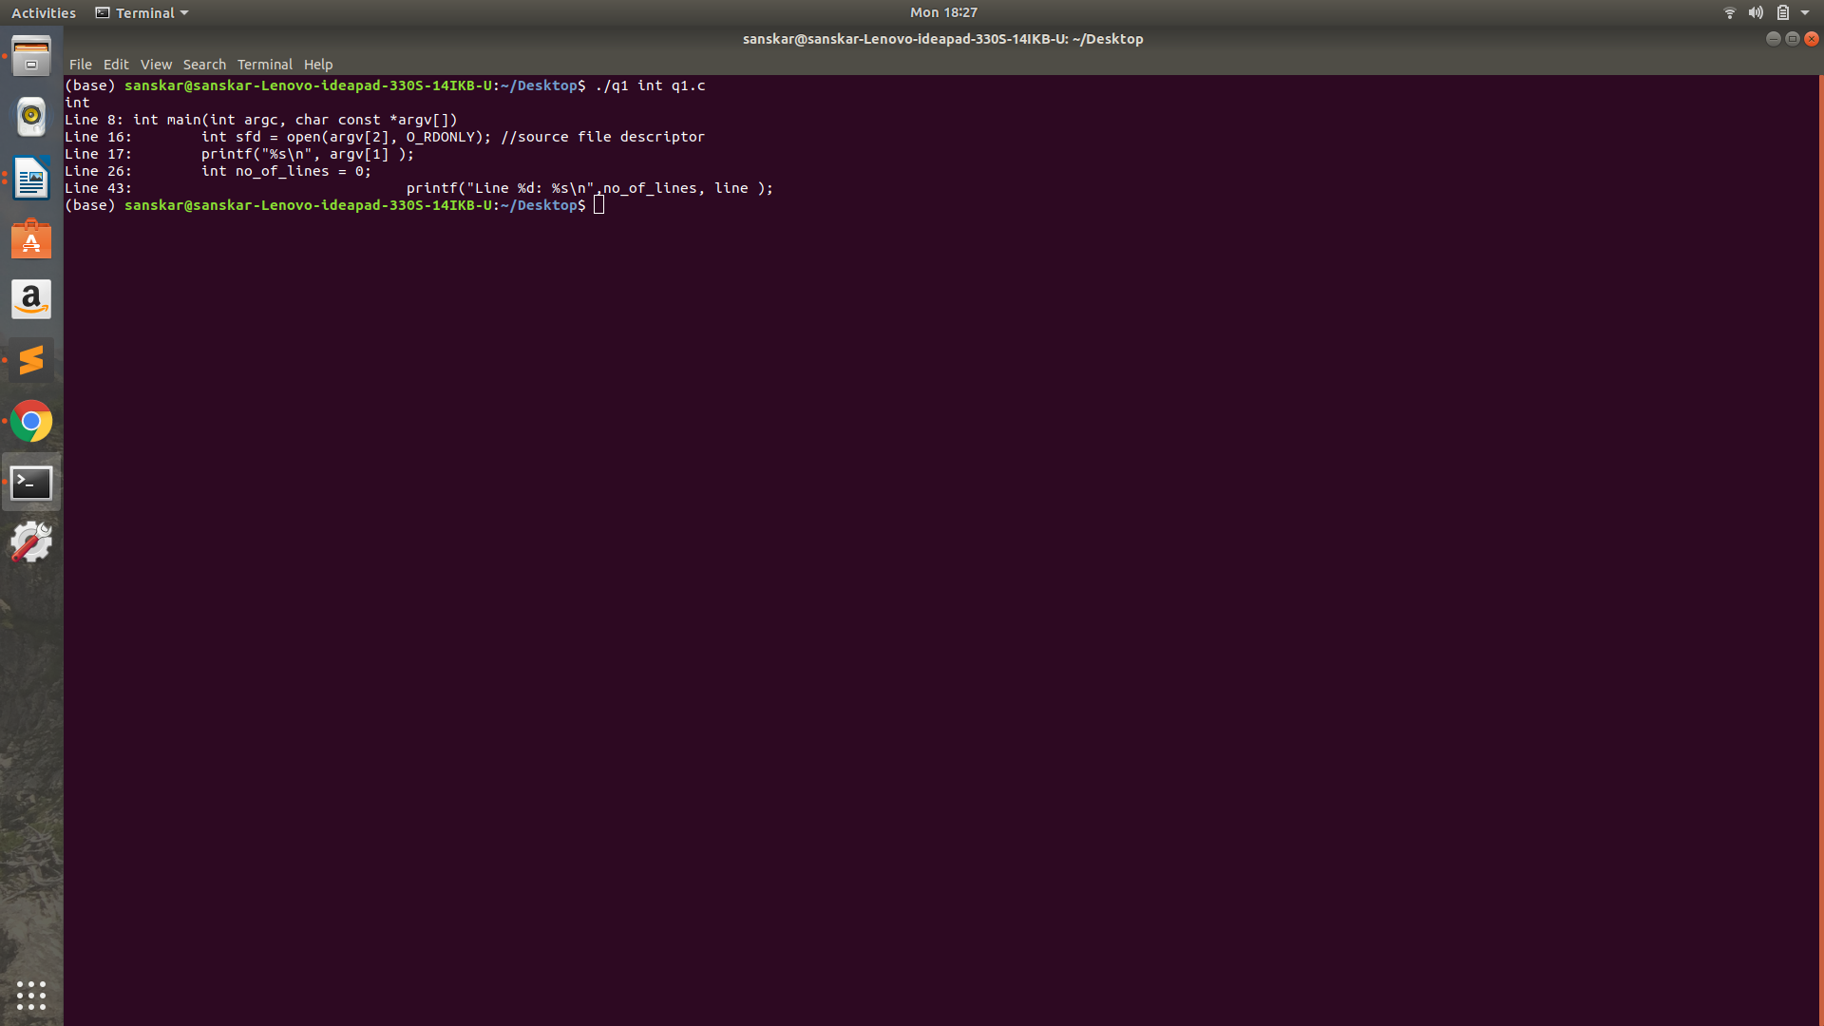

2. MORE
#include<unistd.h>
#include<sys/stat.h>
#include<fcntl.h>
#include<stdlib.h>
#include <string.h>
#include<stdio.h>

int main(int argc, char const *argv[])
{
if(argc<2)
{
write(2, "There should be 2 arguments specified\n", 38);
exit(1);
}

for(int i = 1; i<argc; i++)
{
int sfd = open(argv[i], O_RDONLY); //source file descriptor
printf("\nReading file %s ...\n", argv[i] );
if(sfd==-1)
{
write(2, "Source file does not exist\n", 27);
// exit(1);
continue;
}

char line[100]="";
char c, waste;
int no_of_lines = 0;
int ctr = 0;
while(read(sfd, &c, sizeof(char))>0)
{
if(c!='\n' && c!='\0')
{
strncat(line, &c, 1);
}
else
{
no_of_lines++;
ctr++;
printf("%d: %s\n",no_of_lines, line );
line[0] = '\0';
if(ctr==20)
{
ctr=0;
printf("Enter q(quit) or any other key to continue\n");
fflush(stdin);
// while(read(0, &c, 1)==0);
// c = getchar();
scanf("%c", &c);
if(c!='\n')
scanf("%c", &waste);
fflush(stdin);
if(c=='q')
{
printf("Exiting...\n");
fflush(stdin);
// exit(0);
// continue;
break;
}
}
}
}
// printf("Closing file %s\n\n", argv[i] );
// fflush(0);
close(sfd);
}

// return 0;
exit(0);
}

OUTPUT

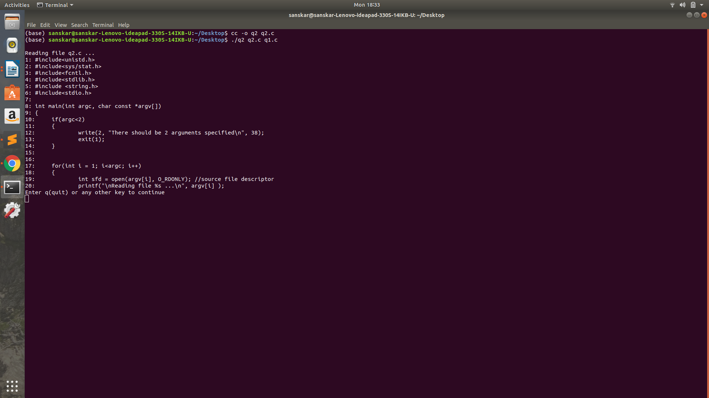

3. CONVERSION SPECIFIERS
#include<stdio.h>
#include<errno.h>
int main(int argc, char const *argv[])
{
int x = -23;
unsigned int y = 25;
float z = 3.14;
double d = 424242.171717;
char c = 'h';
char str[]="Hello world!";
errno = EPERM;

printf("Integer: %d\n", x);
printf("unsigned Integer %u\n", y);
printf("Hexadecimal versionsof both: %#x %#x\n",x, y);

printf("float: %f\n", z);
printf("double %3.3lf\n", d);

printf("STRING %s\n", str);
printf("CHAR %c\n", c);

printf("ERR %m\n" );
return 0;
}

OUTPUT:

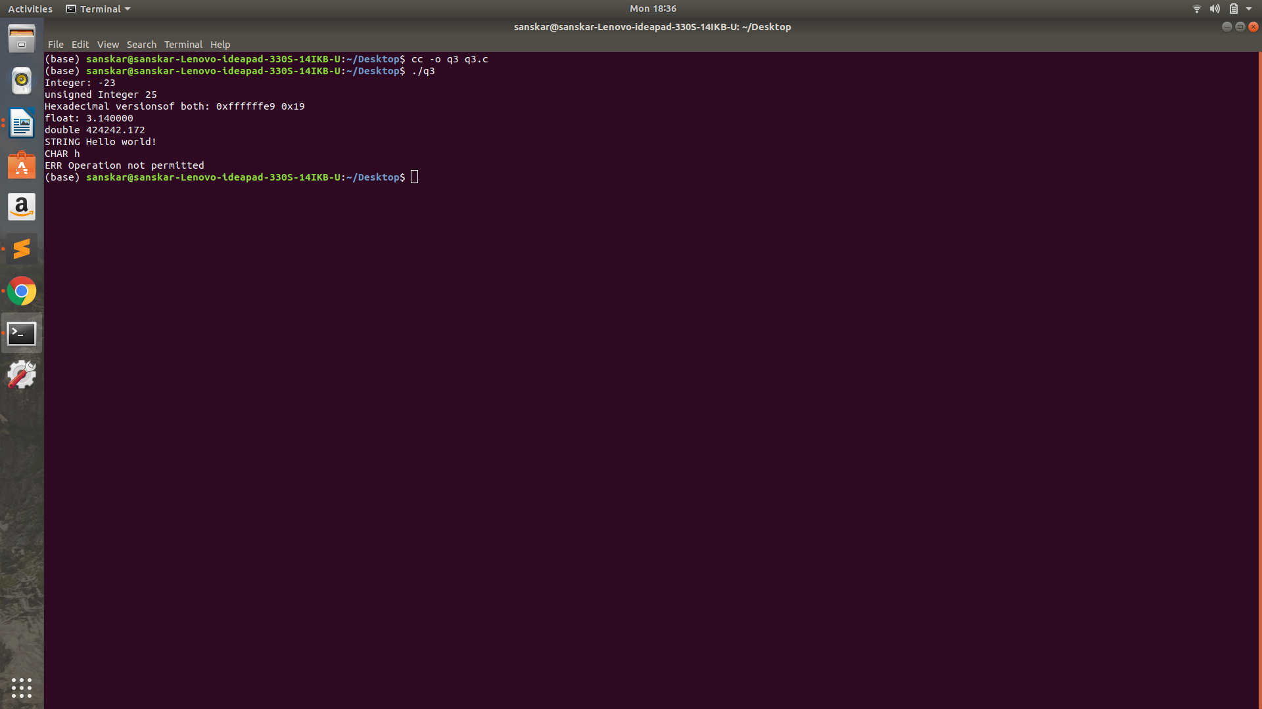

4. COPY
#include<unistd.h>
#include<sys/stat.h>
#include<fcntl.h>
#include<stdlib.h>
#include<stdio.h>
int main(int argc, char const *argv[])
{
// char c;
if(argc!=3)
{
printf("You need to provide 2 files names as input args\n");
exit(1);
}
FILE *in, *out;// file descriptors

in = (FILE*)fopen(argv[1], "r");
out = (FILE*)fopen(argv[2], "w+");

// while(fgetc == 1)
// write(out, &c, 1);
while(1)
{
if(feof(in))
break;
fputc(fgetc(in), out);
}
fclose(in);
fclose(out);
return 0;
}

OUTPUT:

